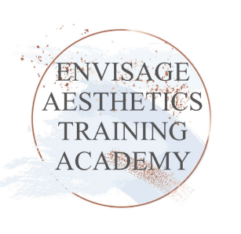  
**Booking a Course**

**The Nurses Clinic. 1-3 Marston Lane, Attleborough, Nuneaton, CV11 4RD.**

All prices are inclusive of VAT

Botulinum Toxin 1 day Course £995 (Botox to upper face and ‘Setting up as a Practitioner’)

Dermal Fillers 1 day £995 (Lip enhancements, Nasolabial folds, marionette, smokers’ lines)

Both days £1690 **a saving of £300**

We accept debit cards, credit cards and bank transfer to Lucy Lower SORT CODE: 04-06-05 ACC NO: 17077468

We will try to accommodate you with regards to your preferred dates.

A deposit of £300 per Course is required to secure your booking. The full balance is due 2 weeks before the Course date. If the full balance is not paid 2 weeks prior to the Course date the deposit will be non-returnable and your Course booking will be cancelled.

**Course Cancellation Terms and Conditions**

Courses cancelled up to 4 weeks before the Course date will be refunded in full.

Courses cancelled within 4 weeks to 8 days before the Course date will be 50% refunded.

Courses cancelled in the 7 days leading up to the Course date will not be refunded.

Upon receipt of payment, you will be sent acknowledgement and your Pre-course materials via the student portal Thinkific. Upon completion of the Course, you will receive a receipt for your records. We recommend printing the manuals or bringing a device to access Thinkific however a note book in order to take notes during the theory and practical sessions is provided along with lunch and refreshments (full day Courses).

Following your Training Day, you will have access to support. Handouts and aftercare forms within your manuals with further useful information. You will also be provided with our WhatsApp contact number for questions or Medical Emergencies involving dermal fillers which will be answered in office hours. Should you be dealing with a Medical Emergency on an Evening then message us via Facebook and we will contact you back.